Computer Assignment 9 - Model Assumptions and Cross Validation

$\text{Machine Learning, Spring 2020}$

Rui Li

## Not-So-Perfect Data for LDA

Recall on the previous CA we performed LDA on a data set that was generated from the LDA model. For that data set the two groups (classified 0 and 1) were generated from two multinormal distributions with the same variance but different means. LDA performed very well on that data because *the data were generated from the underlying LDA model* that we were trying to fit.

In this assignment, we will explore what happens when we apply our methods to a dataset that is generated from a distribution that is *very different* from a LDA model. We will start in two dimensions. Note that while we are still using the multinormal function to generate the following data, the variance of the marginals is different, the means are the same, and we manipulate data_1 in such a way that it is no longer normal. Indeed,

# Make sure to install this package if you do not have it:  
library(mvtnorm)  
my_sigma_1 = t(matrix(c(2,0.2,0.2,2)*0.6, ncol=2)) %*% matrix(c(2,0.2,0.2,2)*0.6, ncol=2)  
my_sigma_2 = t(matrix(c(2,0.2,0.2,2), ncol=2)) %*% matrix(c(2,0.2,0.2,2), ncol=2)  
data_0 = rmvnorm(1000, mean = rep(0, times = 2), sigma = my_sigma_1)  
data_1 = rmvnorm(1500, mean = rep(0, times = 2), sigma = my_sigma_2)  
central_points = ( sqrt( data_1[,1]**2 + data_1[,2]**2) < 1.5 )  
data_1 = data_1[!central_points,]

library(ggplot2)  
temp_data = data.frame(rbind(data_0, data_1))  
temp_data$class = as.factor(c(rep(0, times = 1000), rep(1, times = nrow(data_1))))  
ggplot(temp_data, aes(x = X1, y = X2, color = class)) + geom_point() +   
 ggtitle("Strange Scatters")

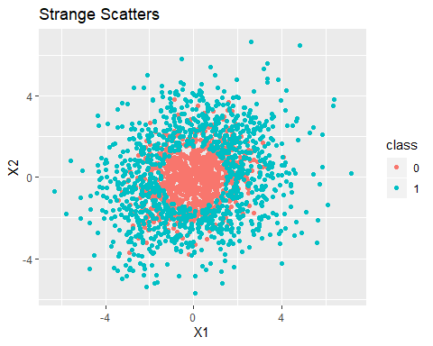

# Questions

1. The way these data were created breaks *two* of the assumptions for LDA. What are they? Do you predict LDA or KNN will have better performance on this data? Defend your choice.

These data breaks two assumptions. First of all, the independent variable of group 1 is not normal. Also, the variance of two groups are different.  
  
Therefore LDA would not perform well on this data. However, KNN will have better performance, because the k-nearest neighbor rules does not follow any assumption. What KNN does is to classify an object by a plurality vote of its neighbors, with the object being assigned to the class most common among its k nearest neighbors.

1. If you were to draw a decision boundary on this data, what shape would it be? Why might this not be a good thing for an LDA model?

The decision boundary would be an oval-shaped, quadric surface. Since the decision boundary of an LDA model shold be a hyperplane, thus this shape is not a good thing for an LDA model.

1. Split the data into a testing data set and a training data set. Build an LDA model on the training data. Use the training data again to predict the class labels and report the performance of your model. What is the error rate? (the proportion of times your model classified an observation incorrectly)

library(MASS)  
library(dplyr)  
#Split the data set to testing data and training data  
training_size <- round(.75 * nrow(temp_data)) # training set size  
indices = sample(1:nrow(temp_data), training_size)  
training_set <- temp_data[indices,]  
testing_set <- temp_data[-(indices),]  
#Build an LDA model  
train_lda = lda(class~., data = training_set)  
train_predictions <- train_lda %>% predict(training_set)  
train_error = sum(train_predictions$class!=training_set$class)/length(training_set$class)  
#Print the result  
print(paste0("The error rate is ", train_error, "."))

## [1] "The error rate is 0.468710888610763."

1. Now predict the class labels using the testing data and report the performance of your model. What is the error rate?

#Build an LDA model  
test_predictions <- train_lda %>% predict(testing_set)  
test_error = sum(test_predictions$class!=testing_set$class)/length(testing_set$class)  
#Print the result  
print(paste0("The error rate is ", test_error, "."))

## [1] "The error rate is 0.479323308270677."

1. Repeat steps 2-3 using a knn model for $k∈\{1,5,11\}$. Considering only the cases where you predicted labels on your testing data, compare the error rates between the LDA model and all of the knn models. Was your prediction in question 1 correct or incorrect?

#knn risk  
library(class)  
train_data_classifiers = as.factor(training_set$class)  
train_data_observations = training_set[,-3]  
test_data_observations = testing_set[,-3]  
test_data_classifiers = as.factor(testing_set$class)  
  
#k=1  
knn.1 <- knn(train_data_observations, test_data_observations, cl = train_data_classifiers, k=1)  
knn.1_risk = sum(test_data_classifiers != knn.1)/length(knn.1)  
print(paste0("The risk of knn.1 is ", knn.1_risk, "."))

## [1] "The risk of knn.1 is 0.257518796992481."

#k=5  
knn.5 <- knn(train_data_observations, test_data_observations, cl = train_data_classifiers, k=5)  
knn.5_risk = sum(test_data_classifiers != knn.5)/length(knn.5)  
print(paste0("The risk of knn.5 is ", knn.5_risk, "."))

## [1] "The risk of knn.5 is 0.223684210526316."

#k=11  
knn.11 <- knn(train_data_observations, test_data_observations, cl = train_data_classifiers, k=11)  
knn.11_risk = sum(test_data_classifiers != knn.11)/length(knn.11)  
print(paste0("The risk of knn.11 is ", knn.11_risk, "."))

## [1] "The risk of knn.11 is 0.214285714285714."

The average risk rate of the three knn models is 0.25, which is much smaller than the risk rate of testing set 0.48, showing that knn has a better performance on this data and my prediction on question 1 was correct.

# Error Rate for Increasing Data Sizes

We will now examine how the error rate stabalizes for larger and larger data sizes. Manipulate the variable data_size in the following code to simulate different sizes of the data we created for the last problem.

data_size = 10  
my_sigma_1 = t(matrix(c(2,0.2,0.2,2)*0.6, ncol=2)) %*% matrix(c(2,0.2,0.2,2)*0.6, ncol=2)  
my_sigma_2 = t(matrix(c(2,0.2,0.2,2), ncol=2)) %*% matrix(c(2,0.2,0.2,2), ncol=2)  
data_0 = data.frame(rmvnorm(data_size, mean = rep(0, times = 2), sigma = my_sigma_1))  
data_1 = data.frame(X1 = NA, X2 = NA)  
count = 0  
while(count < data_size){  
 new_draw = rmvnorm(1, mean = rep(0, times = 2), sigma = my_sigma_2)  
 if( sqrt( new_draw[,1]**2 + new_draw[,2]**2) >= 1.5 ) {  
 data_1 = rbind(data_1, data.frame(new_draw))  
 count = count + 1  
 }  
}  
data_1 = data_1[-1,]  
my_data = data.frame(rbind(data_0, data_1))  
my_data$class = as.factor(c(rep(0, times = data_size), rep(1, times = data_size)))

For data_size $∈\{5,10,25,50,100,200,500,1000,10000\}$ do the following:

* Generate the “Strange Scatters” data using the given code.
* Split the data into testing and training data sets.
* Build an LDA model and the KNN models for $k∈\{1,5,11\}$ on the training data, predict the labels on the training data, and calculate the training error rate.
* Build an LDA model and the KNN models for $k∈\{1,5,11\}$ on the training data, predict the labels on the testing data, and calculate the testing error rate.
* Save both error rates

#Define the data size vector  
size = c(5,10,25,50,100,200,500,1000,10000)  
  
#Initiate the error rate of training and testing  
lda_train = c(); k.1_train = c(); k.5_train = c(); k.11_train = c()  
lda_test = c(); k.1_test = c(); k.5_test = c(); k.11_test = c()  
  
#Loop the data in vector size  
for (data_size in size) {  
 my_sigma_1 = t(matrix(c(2,0.2,0.2,2)*0.6, ncol=2)) %*% matrix(c(2,0.2,0.2,2)*0.6, ncol=2)  
 my_sigma_2 = t(matrix(c(2,0.2,0.2,2), ncol=2)) %*% matrix(c(2,0.2,0.2,2), ncol=2)  
 data_0 = data.frame(rmvnorm(data_size, mean = rep(0, times = 2), sigma = my_sigma_1))  
 data_1 = data.frame(X1 = NA, X2 = NA)  
 count = 0  
 while(count < data_size){  
 new_draw = rmvnorm(1, mean = rep(0, times = 2), sigma = my_sigma_2)  
 if( sqrt( new_draw[,1]**2 + new_draw[,2]**2) >= 1.5 ) {  
 data_1 = rbind(data_1, data.frame(new_draw))  
 count = count + 1  
 }  
 }  
 data_1 = data_1[-1,]  
 my_data = data.frame(rbind(data_0, data_1))  
 my_data$class = as.factor(c(rep(0, times = data_size), rep(1, times = data_size)))  
   
 # Generate the "Strange Scatters" data using the given code  
 plot <- ggplot(my_data, aes(x = X1, y = X2, color = class)) + geom_point() +   
 ggtitle(paste0("Strange Scatters of data size ", data_size,"."))  
 print(plot)  
   
 # Split the data into testing and training data sets  
 library(MASS); library(dplyr)  
 training_size <- round(.75 * nrow(my_data)) # training set size  
 indices = sample(1:nrow(my_data), training_size)  
 training_set <- my_data[indices,]  
 testing_set <- my_data[-(indices),]  
   
 # Build an LDA model and the KNN models for k=1,5,11 on the training data, predict the labels on the training/testing data, and calculate the training/testing error rate  
 ## Build an LDA model  
 train_lda = lda(class~., data = training_set)  
 train_predictions <- train_lda %>% predict(training_set)  
 train_error = sum(train_predictions$class!=training_set$class)/length(training_set$class)  
 lda_train = c(lda_train,train_error)  
   
 test_predictions <- train_lda %>% predict(testing_set)  
 test_error = sum(test_predictions$class!=testing_set$class)/length(testing_set$class)  
 lda_test = c(lda_test,test_error)  
 ##knn risk  
 library(class)  
 train_data_classifiers = as.factor(training_set$class)  
 train_data_observations = training_set[,-3]  
 test_data_observations = testing_set[,-3]  
 test_data_classifiers = as.factor(testing_set$class)  
 ###Train k=1  
 knn.1 <- knn(train_data_observations, train_data_observations, cl = train_data_classifiers, k=1)  
 knn.1_risk = sum(train_data_classifiers != knn.1)/length(knn.1)  
 k.1_train = c(k.1_train,knn.1_risk)  
 ###Train k=5  
 knn.5 <- knn(train_data_observations, train_data_observations, cl = train_data_classifiers, k=5)  
 knn.5_risk = sum(train_data_classifiers != knn.5)/length(knn.5)  
 k.5_train = c(k.5_train,knn.5_risk)  
 ###Train k=1  
 knn.11 <- knn(train_data_observations, train_data_observations, cl = train_data_classifiers, k=11)  
 knn.11_risk = sum(train_data_classifiers != knn.11)/length(knn.11)  
 k.11_train = c(k.11_train,knn.11_risk)  
 ###Test k=1  
 knn.1 <- knn(train_data_observations, test_data_observations, cl = train_data_classifiers, k=1)  
 knn.1_risk = sum(test_data_classifiers != knn.1)/length(knn.1)  
 k.1_test = c(k.1_test,knn.1_risk)  
 ###Test k=5  
 knn.5 <- knn(train_data_observations, test_data_observations, cl = train_data_classifiers, k=5)  
 knn.5_risk = sum(test_data_classifiers != knn.5)/length(knn.5)  
 k.5_test = c(k.5_test,knn.5_risk)  
 ###Test k=11  
 knn.11 <- knn(train_data_observations, test_data_observations, cl = train_data_classifiers, k=11)  
 knn.11_risk = sum(test_data_classifiers != knn.11)/length(knn.11)  
 k.11_test = c(k.11_test,knn.11_risk)  
}

## Warning in knn(train_data_observations, train_data_observations, cl = train_data_classifiers, : k =  
## 11 exceeds number 8 of patterns

## Warning in knn(train_data_observations, test_data_observations, cl = train_data_classifiers, : k =  
## 11 exceeds number 8 of patterns

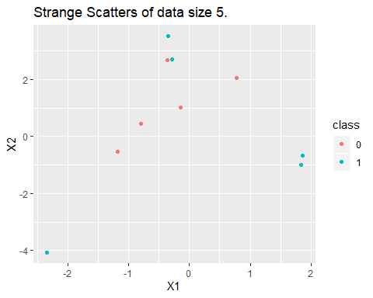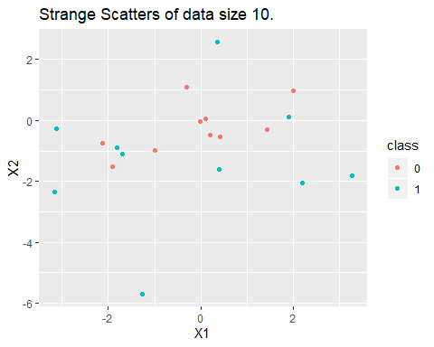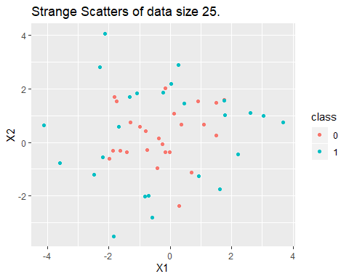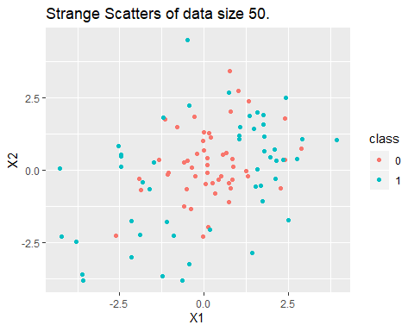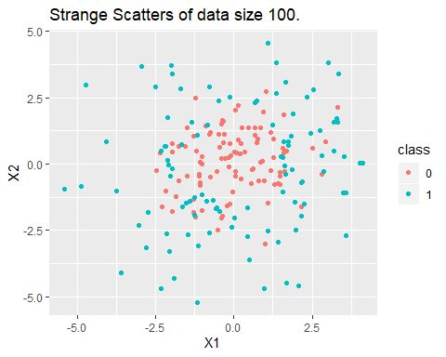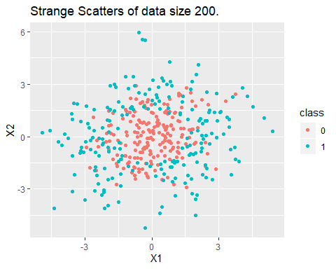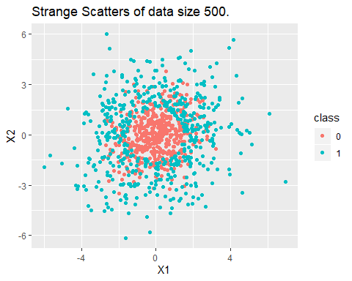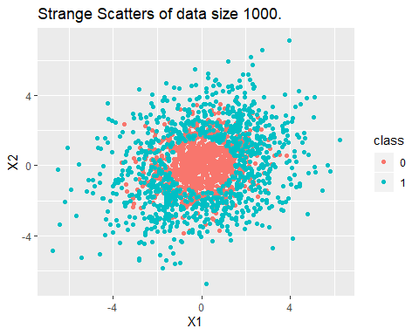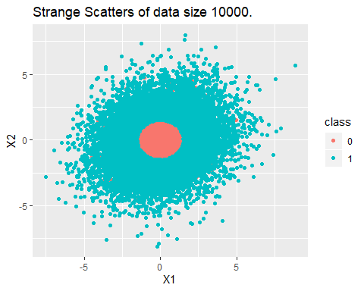

Plot two scatterplots: one for each error type with the data sizes on the $x$-axis, the error rate on the $y$-axis, and color by which model type you used.

Do you notice any trends as your data size increases? Do the error rates “stabilize”?

knitr::opts_chunk$set(error = TRUE)  
library(ggplot2)  
library(reshape)  
#Plot train error rate  
df_train <- data.frame(size, lda_train, k.1_train, k.5_train, k.11_train)  
df_train.melted <- melt(df_train, id = "size")  
ggplot(data = df_train.melted, aes(x = size, y = value, color = variable)) +  
 geom_point()

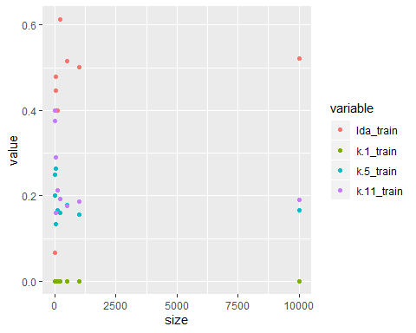

#Plot test error rate  
df_test <- data.frame(size, lda_test, k.1_test, k.5_test, k.11_test)  
df_test.melted <- melt(df, id = "size")  
ggplot(data = df_test.melted, aes(x = size, y = value, color = variable)) +  
 geom_point()

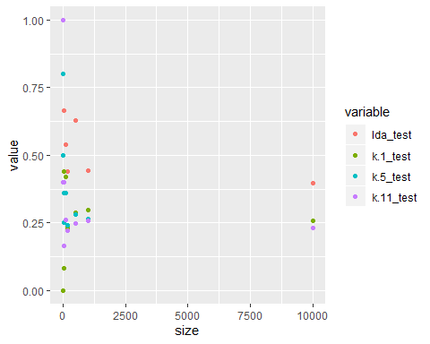

From the two plots, we can see there is a clear trend in test error rate when data size increases. Each model stablilize the error rate between 0.25 to 0.40. The train error rate plot also has the same trend but is not that obvious compared to the test one.

Now compare the testing error rates to the training error rates using boxplots. The modeled used should be on the $x$-axis, the value of the error rate should on the $y$-axis, and you should color by whether the error was calculated on the training or the testing data. Comment on any differences between the testing and the training errors.

knitr::opts_chunk$set(error = TRUE)  
a.ta = data.frame(group = "LDA", value = lda_train)  
b.ta = data.frame(group = "K.1", value = k.1_train)  
c.ta = data.frame(group = "K.5", value = k.5_train)  
d.ta = data.frame(group = "K.11", value = k.11_train)  
  
a.te = data.frame(group = "LDA", value = lda_test)  
b.te = data.frame(group = "K.1", value = k.1_test)  
c.te = data.frame(group = "K.5", value = k.5_test)  
d.te = data.frame(group = "K.11", value = k.11_test)  
  
plot.data.ta = rbind(a.ta, b.ta, c.ta, d.ta)   
plot.data.te = rbind(a.te, b.te, c.te, d.te)  
  
p <-ggplot(plot.data.ta, mapping = aes(x=group, y=value)) +   
 geom_boxplot(col="red")   
p + geom_boxplot(plot.data.te, mapping = aes(x=group, y=value))

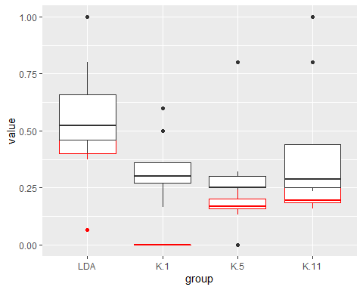

From the boxplot above, red is for the train error rate, while black is for the test error rate. We can notice that generally, the test error rate is more stable and a little bit higher than then the train error rate.

# Introduction to Cross Validation

Use the data generating procedure from the previous section to generate a dataset of size 1000. Perform a 10-fold cross validation based off of the procedure given in the lecture slides. You are **not** permitted to use R’s built in functions to perform this cross validation. Report cross validated (CV) error rate ${\hat{R}}^{10−CV}(ϕ)$ for LDA and for the KNN models where $k∈\{1,5,11\}$. Compare this CV error rate with the error rates you derived in the previous problem for the same data size. What are these two quantities trying to estimate? Are they trying to estimate the same thing?

#Generate 1000 size data  
data_size = 1000  
my_sigma_1 = t(matrix(c(2,0.2,0.2,2)*0.6, ncol=2)) %*% matrix(c(2,0.2,0.2,2)*0.6, ncol=2)  
my_sigma_2 = t(matrix(c(2,0.2,0.2,2), ncol=2)) %*% matrix(c(2,0.2,0.2,2), ncol=2)  
data_0 = data.frame(rmvnorm(data_size, mean = rep(0, times = 2), sigma = my_sigma_1))  
data_1 = data.frame(X1 = NA, X2 = NA)  
count = 0  
while(count < data_size){  
 new_draw = rmvnorm(1, mean = rep(0, times = 2), sigma = my_sigma_2)  
 if( sqrt( new_draw[,1]**2 + new_draw[,2]**2) >= 1.5 ) {  
 data_1 = rbind(data_1, data.frame(new_draw))  
 count = count + 1  
 }  
}  
data_1 = data_1[-1,]  
cv_data = data.frame(rbind(data_0, data_1))  
cv_data$class = as.factor(c(rep(0, times = data_size), rep(1, times = data_size)))

#Cross validatio  
cv_lda = c(); cv_k.1 = c(); cv_k.5 = c(); cv_k.11 = c();  
for (i in 1:10) {  
 indices = c((200*(i-1)+1):(200*i))  
 training_set <- cv_data[-(indices),]  
 testing_set <- cv_data[indices,]  
   
 #LDA  
 train_lda = lda(class~., data = training_set)  
 test_predictions <- train_lda %>% predict(testing_set)  
 test_error = sum(test_predictions$class!=testing_set$class)/length(testing_set$class)  
 cv_lda = c(cv_lda,test_error)  
   
 #knn  
 library(class)  
 train_data_classifiers = as.factor(training_set$class)  
 train_data_observations = training_set[,-3]  
 test_data_observations = testing_set[,-3]  
 test_data_classifiers = as.factor(testing_set$class)  
  
 knn.1 <- knn(train_data_observations, test_data_observations, cl = train_data_classifiers, k=1)  
 knn.1_risk = sum(test_data_classifiers != knn.1)/length(knn.1)  
 cv_k.1 = c(cv_k.1, knn.1_risk)  
 knn.5 <- knn(train_data_observations, test_data_observations, cl = train_data_classifiers, k=5)  
 knn.5_risk = sum(test_data_classifiers != knn.5)/length(knn.5)  
 cv_k.5 = c(cv_k.5, knn.5_risk)  
 knn.11 <- knn(train_data_observations, test_data_observations, cl = train_data_classifiers, k=11)  
 knn.11_risk = sum(test_data_classifiers != knn.11)/length(knn.11)  
 cv_k.11 = c(cv_k.11, knn.11_risk)  
}

# Print and compare the result  
cv.lda = sum(cv_lda)/10; pre_lda = lda_test[8]  
cv.k.1 = sum(cv_k.1)/10; pre_k.1 = k.1_test[8]  
cv.k.5 = sum(cv_k.5)/10; pre_k.5 = k.5_test[8]  
cv.k.11 = sum(cv_k.11)/10; pre_k.11 = k.11_test[8]  
  
print(paste0("For LDA, the CV error rate is ", cv.lda, ", the previous error rate is ", pre_lda, "."))

## [1] "For LDA, the CV error rate is 0.9985, the previous error rate is 0.52."

print(paste0("For Knn-1, the CV error rate is ", cv.k.1, ", the previous error rate is ", pre_k.1, "."))

## [1] "For Knn-1, the CV error rate is 0.3165, the previous error rate is 0.27."

print(paste0("For Knn-5, the CV error rate is ", cv.k.5, ", the previous error rate is ", pre_k.5, "."))

## [1] "For Knn-5, the CV error rate is 0.306, the previous error rate is 0.25."

print(paste0("For Knn-11, the CV error rate is ", cv.k.11, ", the previous error rate is ", pre_k.11, "."))

## [1] "For Knn-11, the CV error rate is 0.3115, the previous error rate is 0.248."

Compared with the error rate, we can notice that the LDA model estimate the data very different, because the CV error rate is much larger than the previous error rate. While the CV shows LDA modeling the data very bad, the non-CV shows LDA modeling quite well. However, the error rates between CV and non-CV are quite close, indicating that they estimate the data similarly and quite well.

What do the CV error rates for LDA and KNN tell us about which of these procedures is better for data generated from our given distribution?

Compared the CV error rate of LDA and KNN, we can see generally, knn has a much slower error rate of 0.3, and the LDA has a higher error rate of 0.98. Thus, Knn (KNN-11) is better for data generated from our given distribution.

In the previous problem, we derived the non-CV testing and training error rates for a data_size of 1000. What did those error rates tell us about the *classification rules* calculated for that particular data set? Can we use these non-CV results to say anything about the procedures we used?

lda.train = lda_train[8]; lda.test = lda_test[8]  
k.1.train = k.1_train[8]; k.1.test = k.1_test[8]  
k.5.train = k.5_train[8]; k.5.test = k.5_test[8]  
k.11.train = k.11_train[8]; k.11.test = k.11_test[8]  
  
print(paste0("For LDA, the train error rate is ", lda.train, ", the test error rate is ", lda.test, "."))

## [1] "For LDA, the train error rate is 0.502, the test error rate is 0.52."

print(paste0("For Knn-1, the train error rate is ", k.1.train, ", the test error rate is ", k.1.test, "."))

## [1] "For Knn-1, the train error rate is 0, the test error rate is 0.27."

print(paste0("For Knn-5, the train error rate is ", k.5.train, ", the test error rate is ", k.5.test, "."))

## [1] "For Knn-5, the train error rate is 0.156, the test error rate is 0.25."

print(paste0("For Knn-11, the train error rate is ", k.11.train, ", the test error rate is ", k.11.test, "."))

## [1] "For Knn-11, the train error rate is 0.186666666666667, the test error rate is 0.248."

These error rates tell us that for a specific data set, not all classification rule will apply. We should find the most satisfied one. From the non-CV results, we can see that KNN can perform this data set the best with a lower error rate